**Name:-Mustafa Khericha**

**Module -1: Understanding of Hardware and Its Components**

Section 1: Multiple Choice

1. Which of the following is NOT a component of the CPU?

1. ALU

2. RAM

3. CU

4. 1 and 3 both

Ans :- Ram , it is a separate component used for temporary data storage.

2. What is the function of RAM in a computer?

Ans :- RAM holds the data and program that the CPU is currently using so that they can be accessed quickly.

3. Which of the following is a primary storage device?

1. HDD

2. SSD

3. SD card

4. 1 and 2 both

Ans : RAM

4. What is the purpose of a GPU?

Ans :- Graphics Processing Unit(GPU) is used to process graphics and visual data quickly and efficiently. It is designed for to process images, videos, and animations.

Section 2:True or False

5. The motherboard is the main circuit board of a computer where other components are attached.

Ans:-True, because other components like RAM,SSD,PCI,CPU etc are attached.

6. A UPS (Uninterruptible Power Supply) is a hardware device that provides emergency power to a load when the input power source fails.

Ans:-True ,Yes it is a hardware device which is used in the case when computer power fails suddenly due to voltage down.

7. An expansion card is a circuit board that enhances the functionality of a component.

Ans:-True, it is inserted into the slot of the motherboard to fix a functionality like graphic card, sound card are used.

Section 3:Short Answer

8. Explain the difference between HDD and SSD.

Ans:-

|  |  |
| --- | --- |
| **HDD** | **SSD** |
| 1.The full from of HDD is Hard Disk Drive. | 1.The full from of SSD is Solid State drive. |
| 2.It is heavy in weight. | 2.It is light in weight. |
| 3.It access in 5-10 ms. | 3.It access in 0.1 ms. |
| 4.It is low reliable. | 4.It is highly reliable. |
| 5.It consumption power of 6-12 watts. | 5.It consumption power of 2 watts. |
| 6.It is less expensive. | 6.It is more expensive. |
| 7.It creates slight noise. | 7.It works silently. |
| 8.It is upto 10TB or more. | 8.It is upto 4TB. |
| 9.It provides more heat. | 9.It provides less heat. |
| 10.It types are AATA,PATA,SATA. | 10.Its types are NVMe,M.2,SATA. |
| 11.It reads data in high time. | 11.It reads data in very low time. |

9. Describe the function of BIOS in a computer system.

Ans:-

10. . List and briefly explain three input devices commonly used with computers.

Ans:- **1. Keyboard**

1)It is used to type alphabets, numbers, special characters.

2)It is also used to type commands and has a function keys and also entering data.

**2. Mouse**

1) Used to control the movement of the pointer on the screen.

2)Allows users to click, drag, and select items. It often includes left/right buttons and a

scroll wheel for navigation.

**3. Scanner**

1. It converts physical documents and images into digital format.
2. Useful for digitizing photos, forms, and printed materials to store or edit them on a computer.

Section 4: Practical Application

11. Identify and label the following components on a diagram of a motherboard:

● CPU ● RAM slots ● SATA connectors

Ans:- 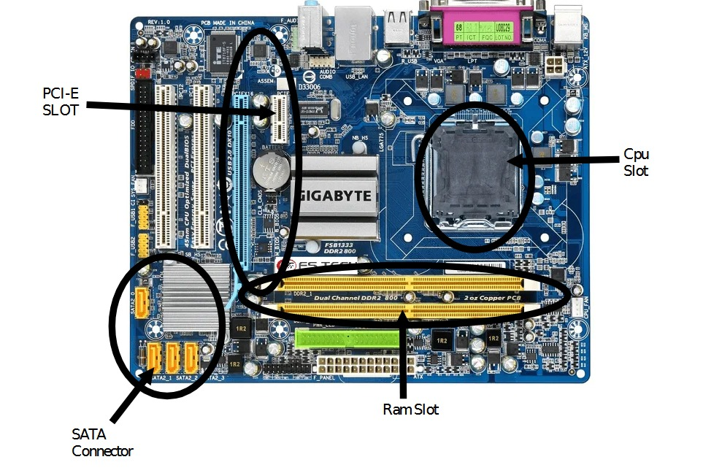

12. Demonstrate how to install a RAM module into a computer.

Ans:-

1. Turn Off and Unplug the Computer

2. Open the Computer Case

3. Locate the RAM Slots on the Motherboard

4. Check RAM Orientation

5. Insert the RAM Module

6. Close the Case and Reconnect

7. Power On the PC

8. Verify In the Operating System

13. Discuss the importance of proper cooling mechanisms in a computer system. Include examples of cooling methods and their effectivenes.

Ans:- COMMON COOLING METHODS: -

1. AIR COOLING: -

Air cooling uses fans and heat sinks to remove heat from the component. It is the most used common method found in desktops and laptops.

It is affordable, reliable, and easy to maintain but less efficient for very high-end system.

Good for everyday use, gaming, and general workloads.

2. LIQUID COOLING: -

Liquid cooling uses water or coolant to transfer heat away from the component, usually through a radiator and fans.

Better performance but more expensive and harder to install; it is also have a risk of leaks.

It is more efficient than air cooling, especially for powerful CPUs and GPUs.

14. Explain the concept of bus width and its significance in computer architecture.

Ans:- A bus is a communication system that transfers data between components such as the CPU, RAM,SSD and input/output devices.

Bus measured in bits (e.g., 8-bit, 16-bit, 32-bit, 64-bit).

It represents how many bits of data can be transferred at one time between components.

Types of Buses:-

1)Data Bus:-

It transfers data between CPU and RAM.

2)Address Bus:-

It carries memory address from CPU.

3)Control Bus:-

It carries control signals.